|  |  |  |  |  |  |
| --- | --- | --- | --- | --- | --- |
| Date | 29-Nov-22 | | | Tester Name | Richard Belanger |
| Environment | Penfax - Test | | | Login used | TEST2 |
| Operating System | Windows | Version: | Update: | | |
| Software Used | Edge | Version: | Update: | | |
| Not Applicable | Version: | Update: | | |
| Release version | 22.4.1 | | | | |
| Title | General 10 month member eligible for reduced pension and other service types | | | | |
| Test Type | Regression | | | | |
| Test Scenario | Terminate member for the purposes of Retirement | | | | |
|  |  | | | | |
| Expected Results | The member will be terminated and placed on Pension | | | | |
| Pass/Fail | Select | | | JIRA# | N/A |

Describe your steps with screenshots:

Member is Ten Month and Eligible for an Reduced Pension with other service types

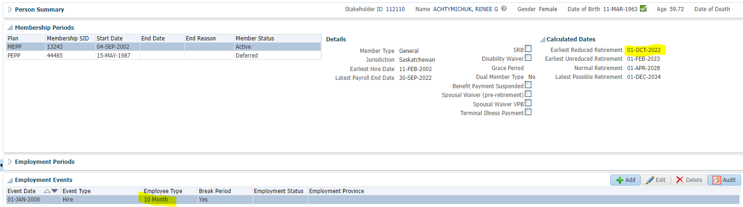

Other Service type LOA Contrib. Service

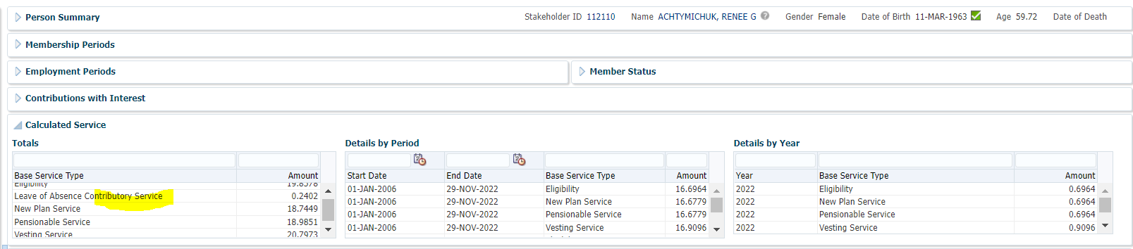

Terminate member for purposes of retirement

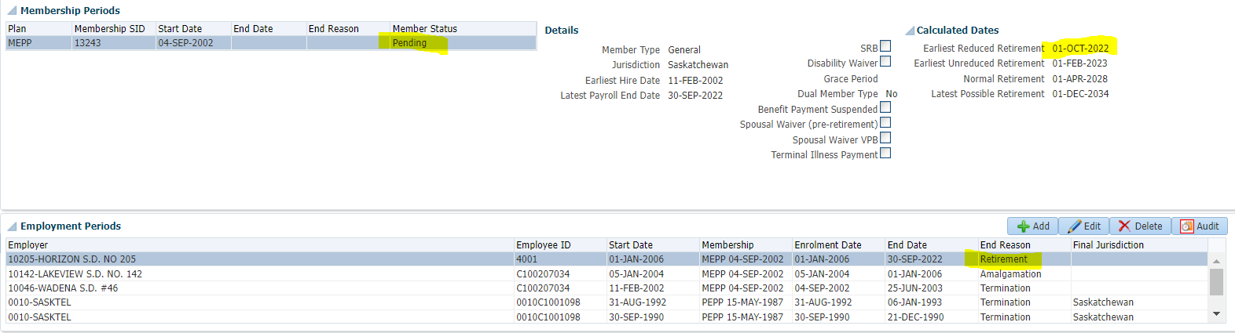

To Benefit Calculation>Calculate

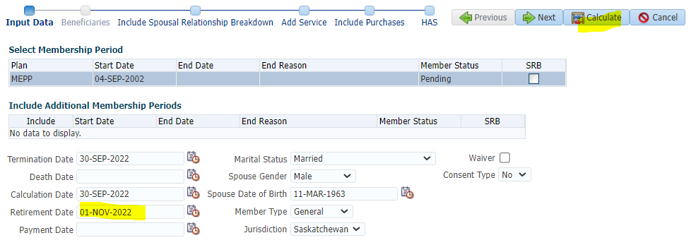

Process

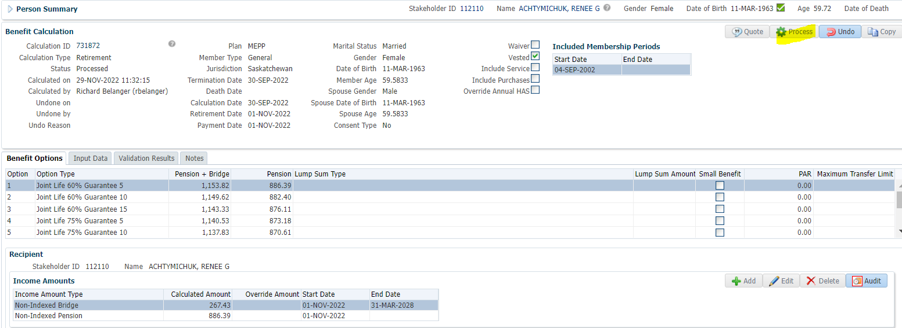

Processed>To Benefit Selection>Next

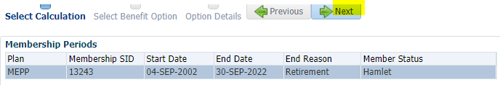

Next

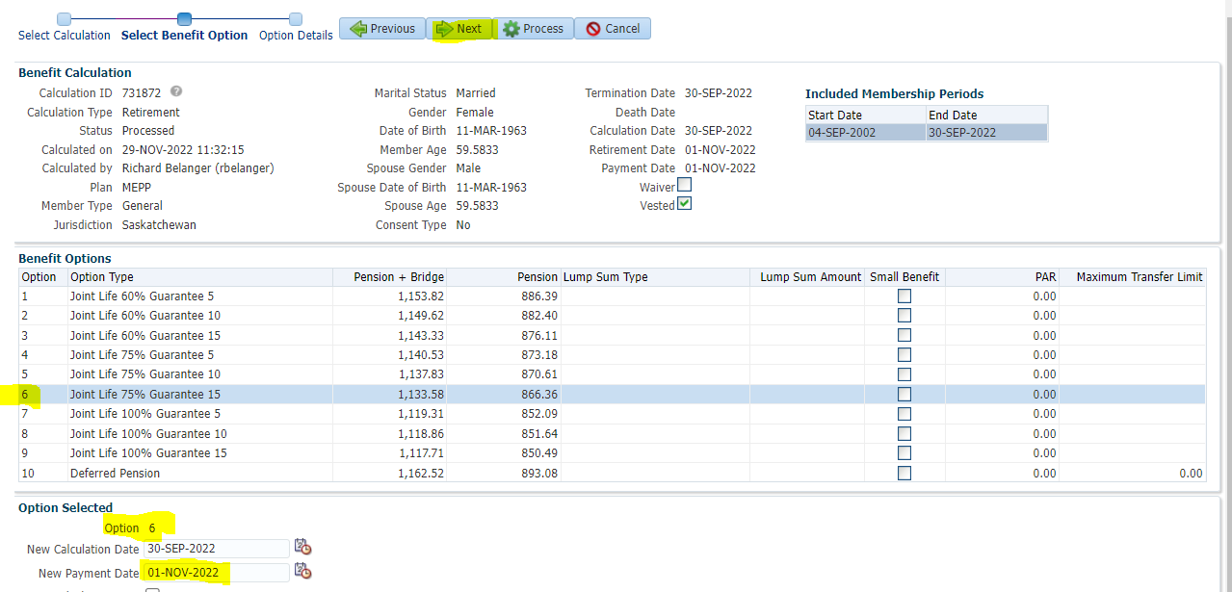

Payment Instructions added; Tax Instructions added>Process

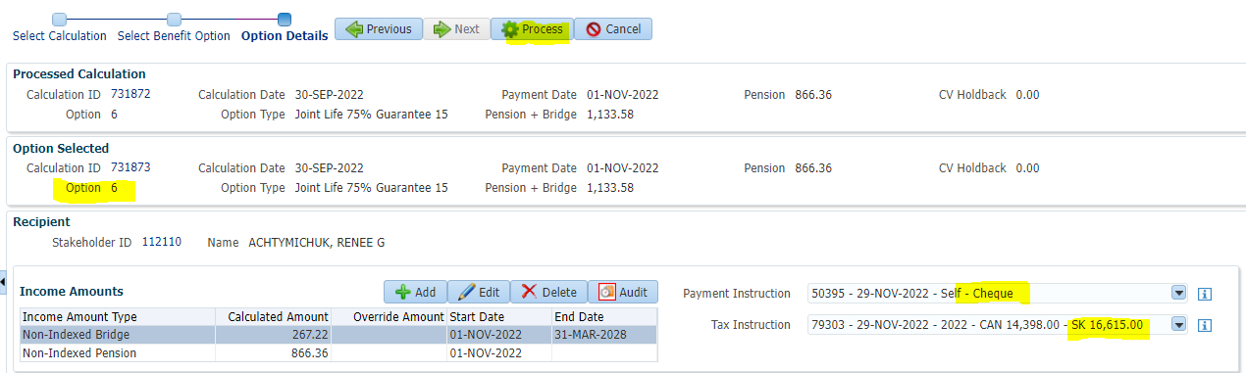

Member is Pensioned

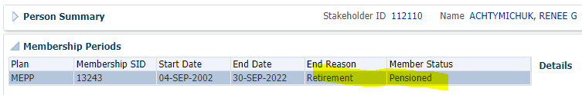

To Benefit Recipient

Income Benefit

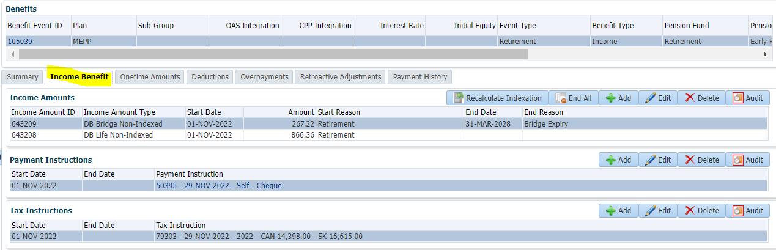

To Summary to Authorize>Authorized

